 |  | TERMO DE ACEITE TÉCNICO
Solicitante: VIVO- Projeto Escolas Rurais
NOC/Operador: Rogerio Momi Frias |  |  | Cliente: VIVO
Empresa  EMC Brasil | VSAT-ID  VIVO-PER-31094145-MG |  | Link kbps  256/128 | Plataforma  VSAT
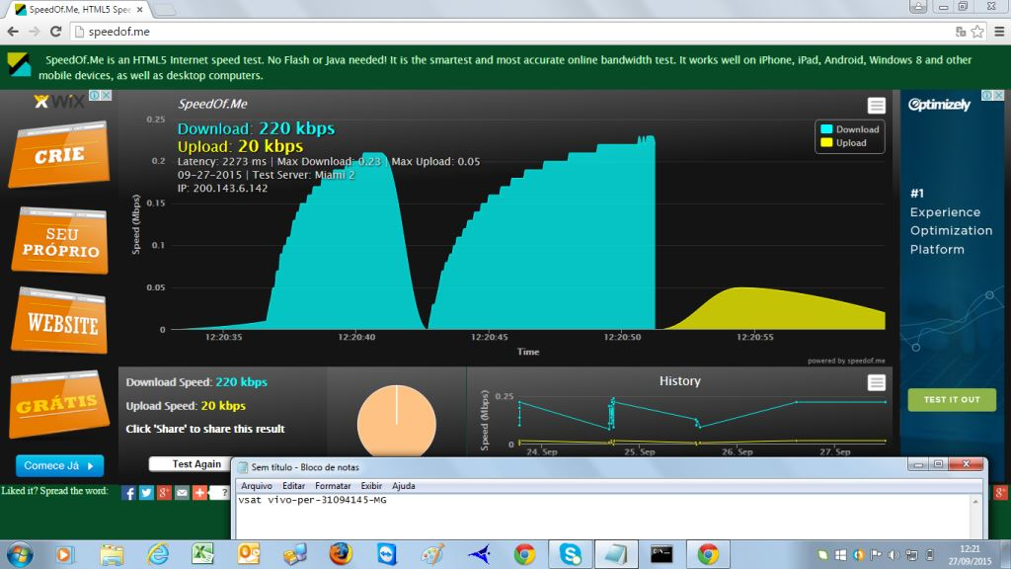

Satellite (DVB) RX Configuration
--------------------------------
Auto start : Enabled
Max MODCOD : 23 16APSK-9/10 (SNR threshold: 23.5 dB)
RX watchdog : 15 minute

Idx Pri SymbRate[Msps] Freq[GHz] Mode PopId Enable
* 0 0 9.320000 12.055285 DVB-S2 4 Yes
1 1 0.000000 0.000000 DVB-S2 2 No

Satellite (DVB) Receiver Status
--------------------------------
Rx State : On
DVB State : Forward link up
Network : 1326, GlobalIP@Telstar-14R
Frequency : 12.055830 GHz
Symbol Rate : 9.320067 Msps
S2 ModCod
- receiving : 16 8PSK-8/9
- current max : 23 16APSK-9/10
Pilot : On
Frame length : Short
DVB S2 Mode : ACM
Roll off : 0.25
SNR : 14.5 dB
Input Power : -28 dBm

Satellite (DVB) TX Configuration
--------------------------------
Auto start : Enabled
IDU Output Power : -30 dBm
IDU Max Output Power: 0.0 dBm
ODU Output Power : 34.7 dBm
EIRP : 48.0 dBW
Default CW Frequency: 0.000000 GHz
ATM mode : VC-Mux
Header Compression : None

Satellite (DVB) Transmitter Status
--------------------------------
State : On (TDMA)
IDU Output Power : -22.2 dBm
ODU Output Power : 34.4 dBm
EIRP : 47.7 dBW
Eb/No : 14.5 dB
Header Compression : Disabled
Timing correction : -174 us (260924 us)
Frequency correction: -370 Hz

Pinging 10.53.0.200 with 32 bytes of data:

Reply from 10.53.0.200: bytes=32 time=1089ms TTL=61
Reply from 10.53.0.200: bytes=32 time=1847ms TTL=61
Reply from 10.53.0.200: bytes=32 time=3135ms TTL=61
Reply from 10.53.0.200: bytes=32 time=1485ms TTL=61

Ping statistics for 10.53.0.200:
Packets: Sent = 4, Received = 4, Lost = 0 (0% loss),
Approximate round trip times in milli-seconds:
Minimum = 1089ms, Maximum = 3135ms, Average = 1889ms

Pinging 10.29.3.225 with 32 bytes of data:

Reply from 10.29.3.225: bytes=32 time=2938ms TTL=61
Reply from 10.29.3.225: bytes=32 time=2936ms TTL=61
Reply from 10.29.3.225: bytes=32 time=556ms TTL=61
Reply from 10.29.3.225: bytes=32 time=4003ms TTL=61

Ping statistics for 10.29.3.225:
Packets: Sent = 4, Received = 4, Lost = 0 (0% loss),
Approximate round trip times in milli-seconds:
Minimum = 556ms, Maximum = 4003ms, Average = 2608ms

ping 8.8.8.8
64 bytes from 8.8.8.8: time=940 ms
64 bytes from 8.8.8.8: time=580 ms
64 bytes from 8.8.8.8: time=920 ms
64 bytes from 8.8.8.8: time=2740 ms
64 bytes from 8.8.8.8: time=1830 ms

--- 8.8.8.8 ping statistics ---
5 packets transmitted, 5 received, 0.00 percent packet loss
rtt min/avg/max = 580/1400/2740 ms

